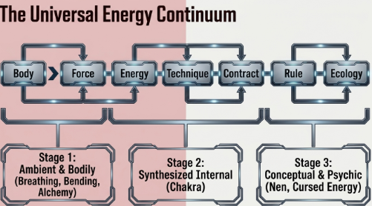
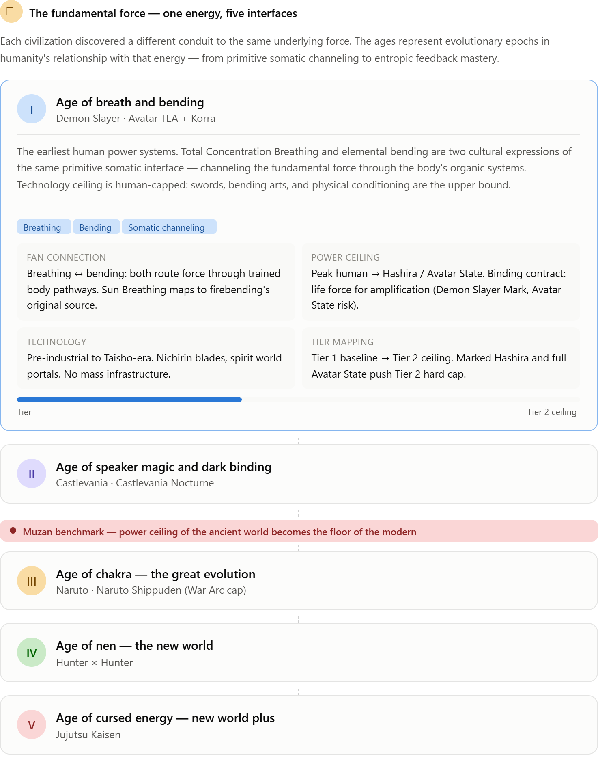
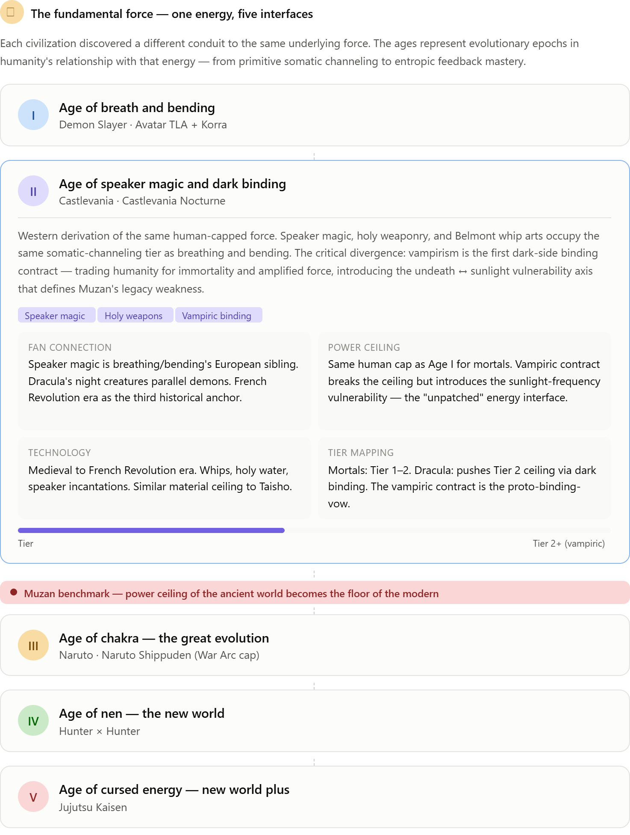
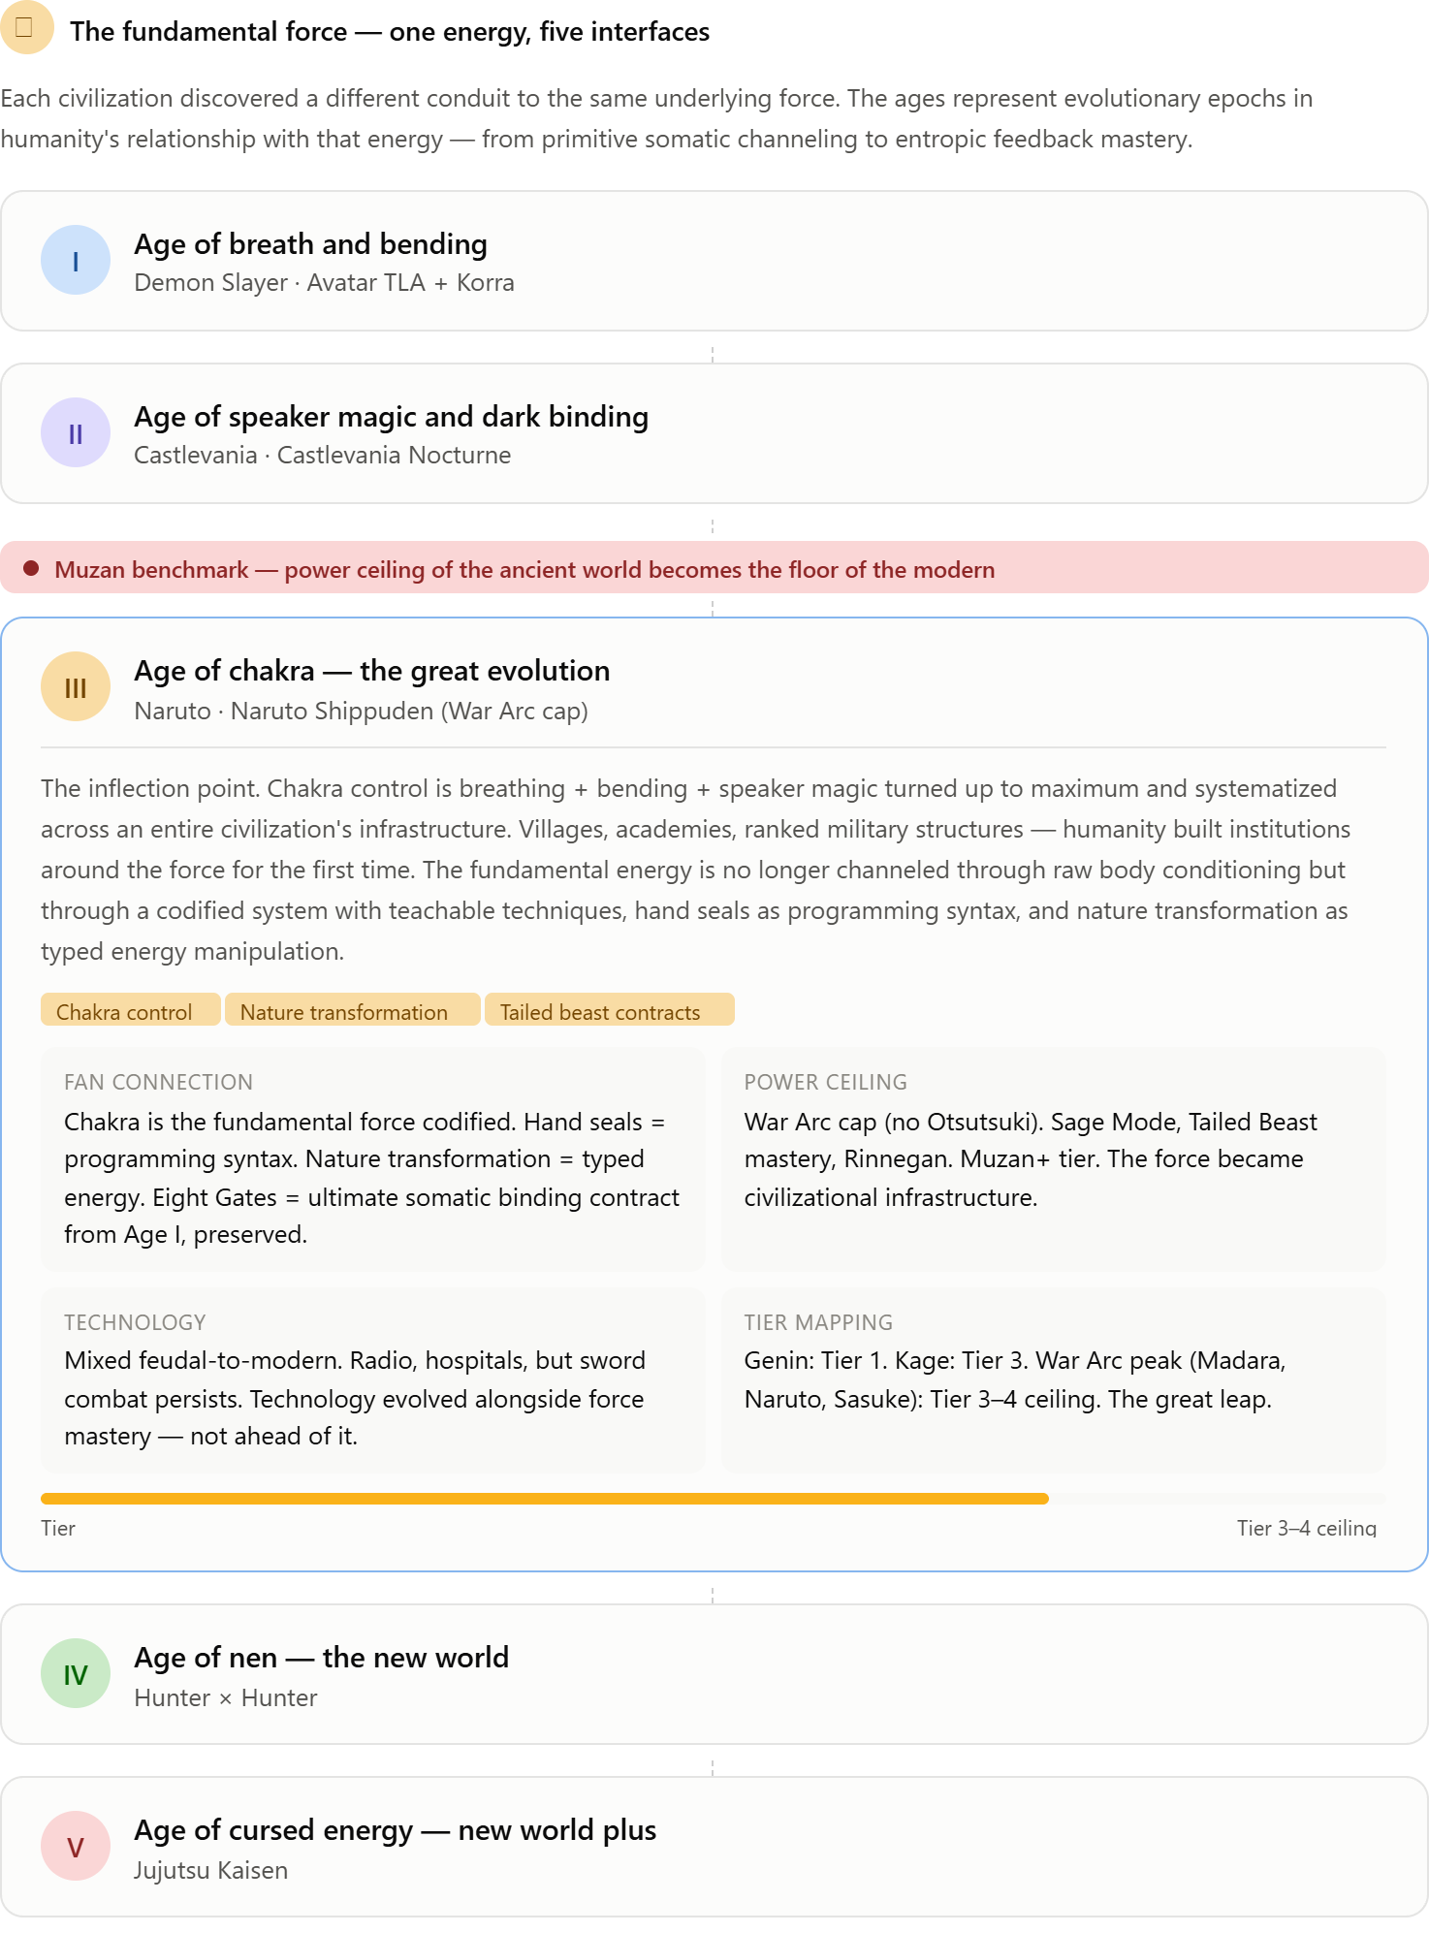
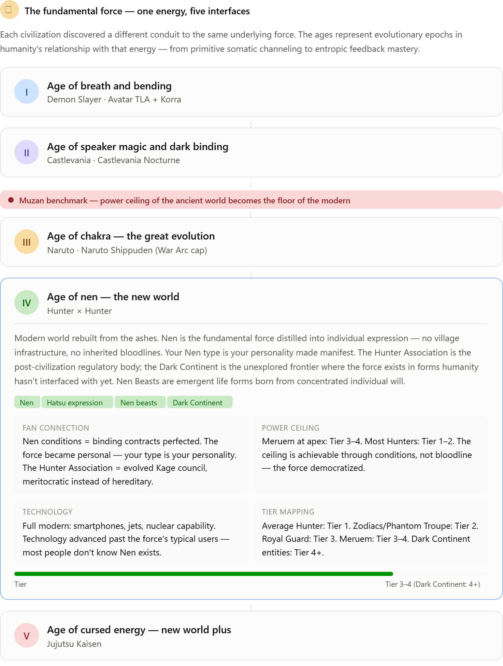
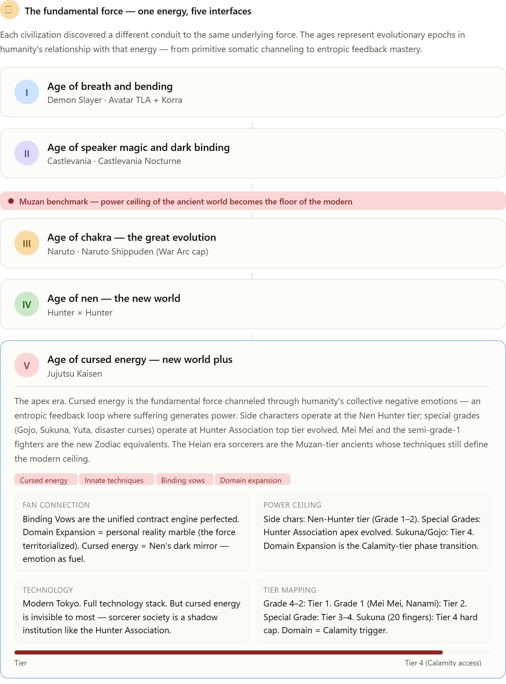
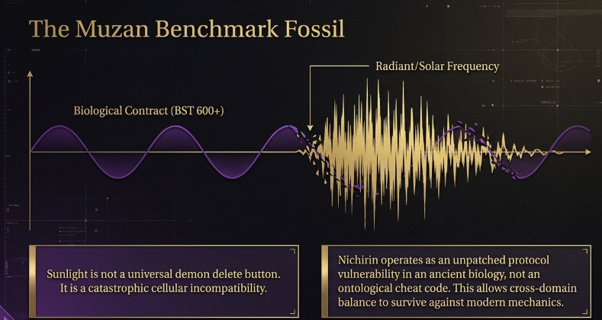
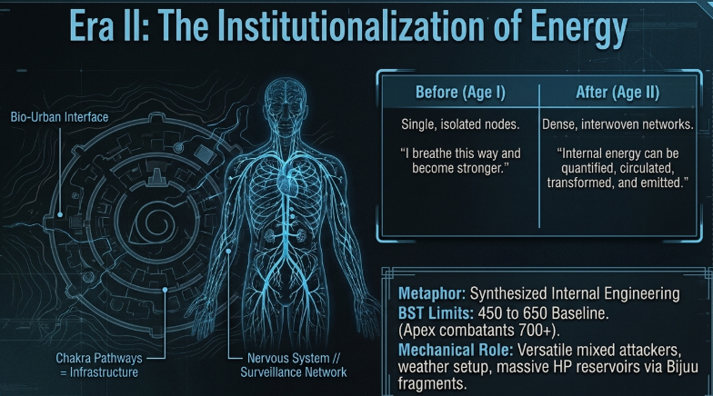

Stub A: The BST Ladder (Floor, Ceiling, Fossils)
The elegant thing in your slides is that you've separated baseline from fossil. Era I isn't capped at 520 — it's normally distributed around 300–520, with Muzan as a 600+ benchmark fossil who broke the band through a biological contract. That gives you a rule you can repeat forever:
- Institutionalization raises the floor. Teachable energy systems push the baseline up each era. Breathing is lineage-locked (low floor) → chakra is academy-taught (higher floor) → nen/cursed energy is society-permeated (higher still).
- Fossils break the ceiling by a fixed margin, never a doubling. Every era gets anomaly-tier units ~+80–120 over its baseline top, via contract, pact, or technique. This keeps cross-era play legible — a fossil from an older era can brawl with mid-tiers of a newer one but loses to that era's titles. That's exactly the "cross-domain balance" your second slide demands.
Draft ladder:
Table
Era | Baseline | Fossil / Anomaly Tier | Anchors
I — Embodied Forces (DS × Avatar) | 300–520 | 560–640 | Muzan 600+, Yoriichi ~620 (human ceiling fossil)
I-W — Western branch (Castlevania) | 300–520 | 560–640 | Dracula ~610, Belmonts cap ~520
III — Great Refinement (Naruto) | 380–560 | 600–700 | Kage/S-rank 620–660; endgame Naruto/Sasuke ~680
IVa — New World (HxH) | 420–600 | 620–680 | Netero ~660; Chimera Ant royals 640–670
IVb — New World Plus (JJK) | 460–620 | 660–760 | Gojo 760, Sukuna 740–760, Yuta ~700
Dark Continent | — | 780+, reserved, unexplored | No stat reveals, only silhouettes
- Era shapes the stat spread, not just the total. From your Era I slide: biologically human means glass-cannon spreads — high Speed/Attack, hard-capped HP. Chakra era = all-rounder spreads with spiky SpAtk. Nen/JJK era = bulky specialists with hax abilities. Dark Continent = no shape rules at all. Same BST can therefore feel completely different depending on which era shaped it.

Stub B: Typing — "What" vs. "How"
I'd split this into two layers, because your setting already contains both:
Primary type = identity (the signature art): Flame, Water, Thunder, Wind, Earth, Solar, Demonic, Martial/Steel, Faith/Speaker, Void, Beast, etc. One shared chart of ~14–16 types that every era's vocabulary normalizes into — Flame Breathing, fire-nature chakra, and transmuter aura all read as the same Flame type.
Era energy frame = expression. Same type, different move pool and stat expression:
- Flame under Breath = physical sweeps (sword arcs)
- Flame under Chakra = ranged AoE ninjutsu
- Flame under Nen = aura burn, sustained damage fields
- Flame under Cursed Energy = cursed technique bursts with hax riders
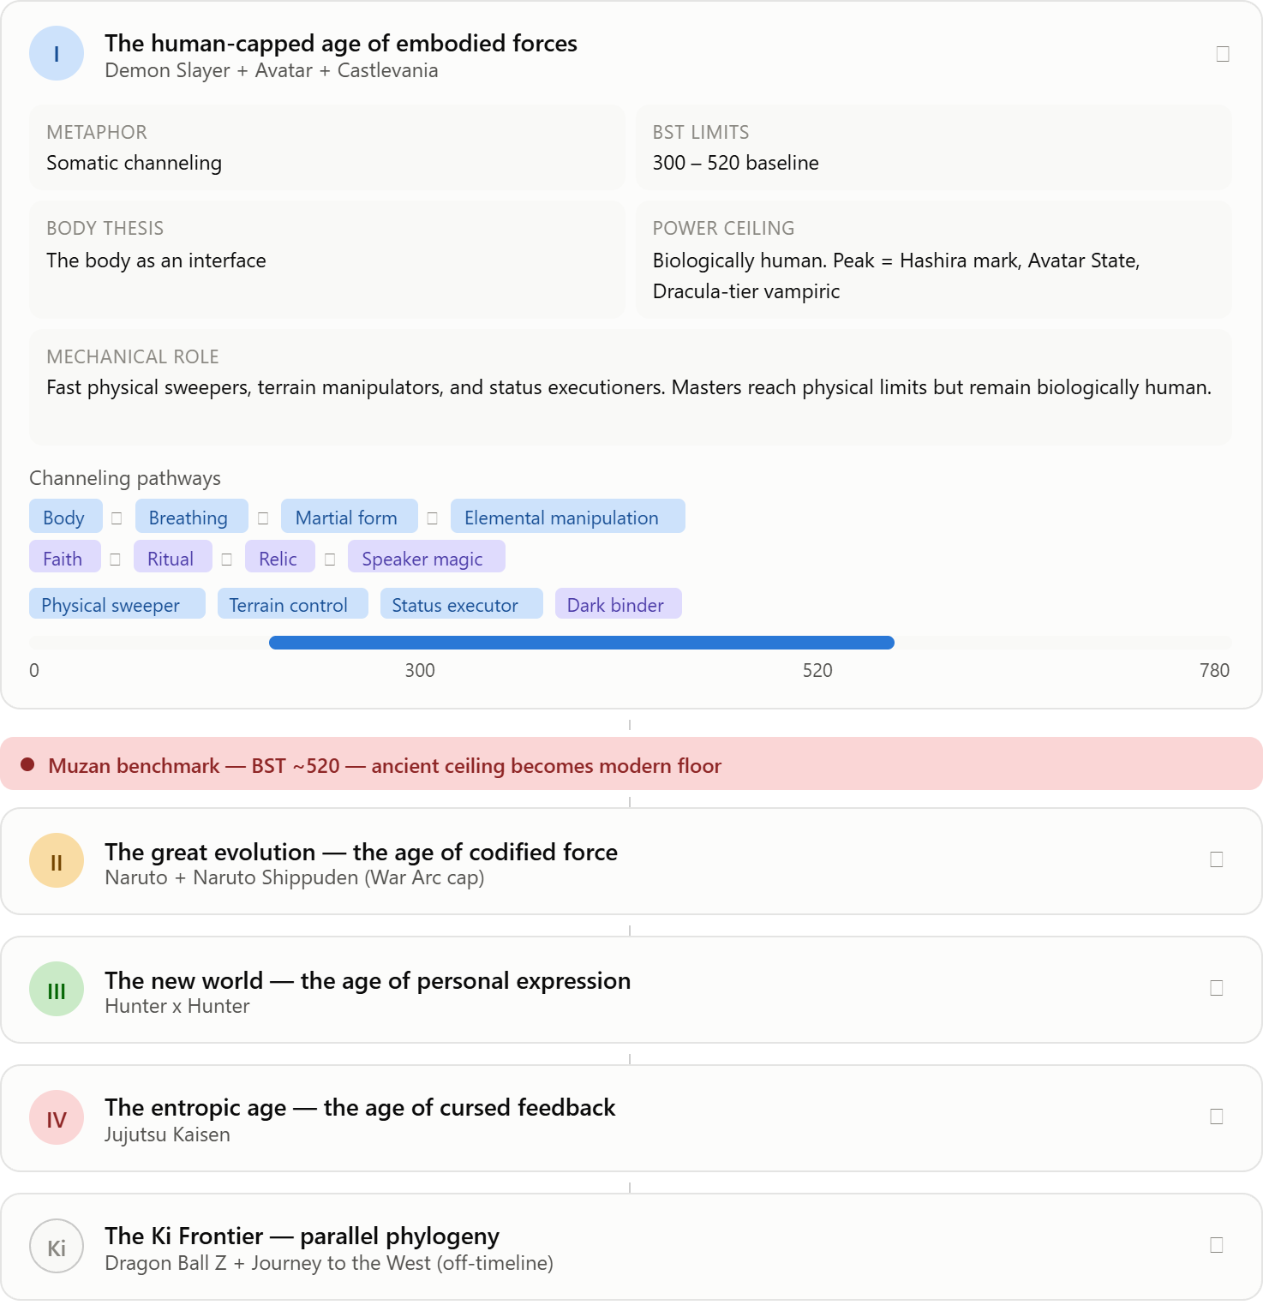
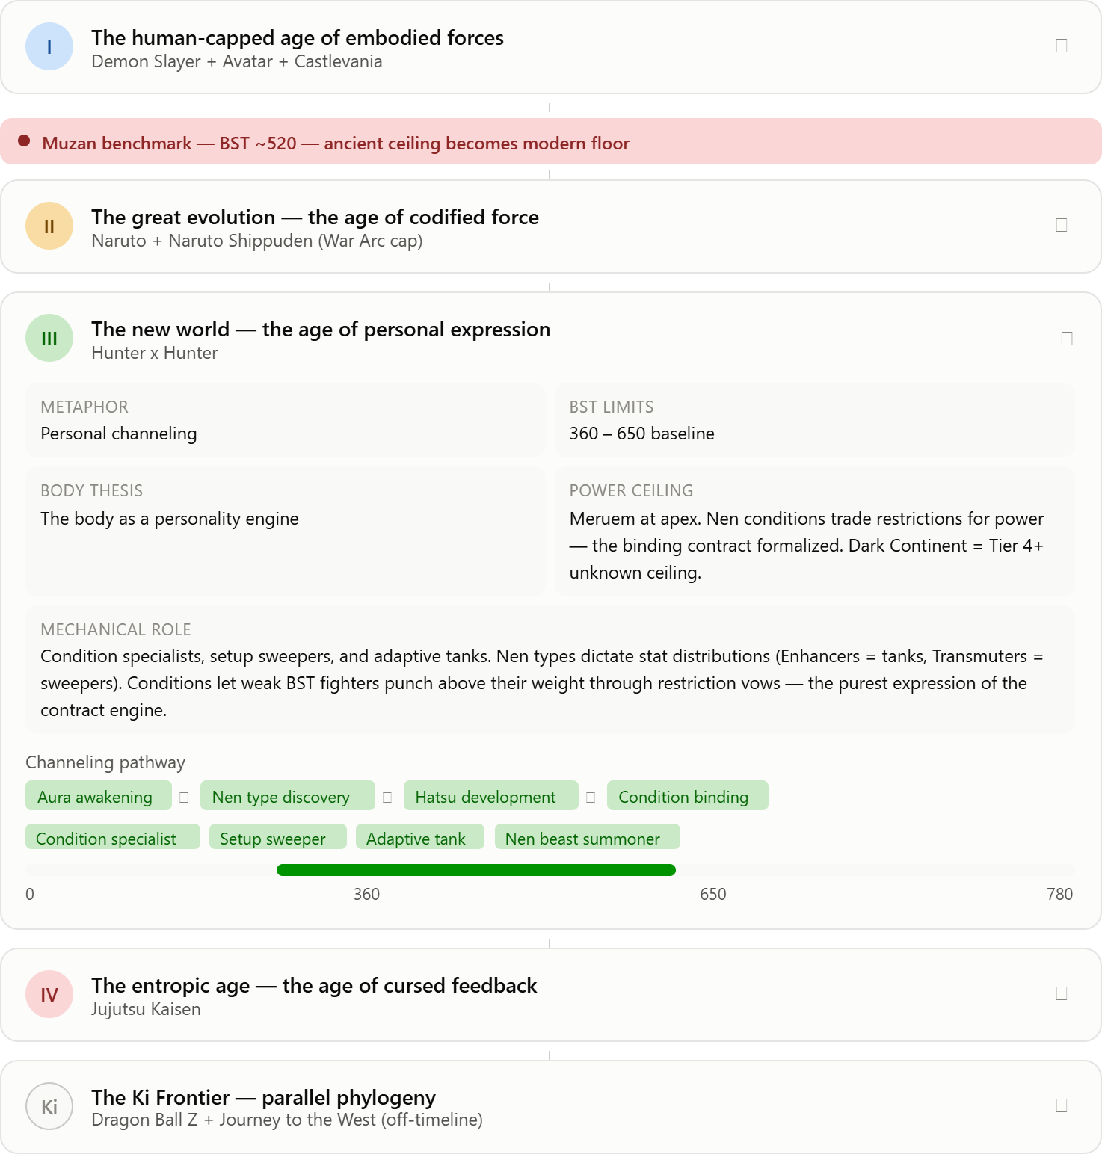
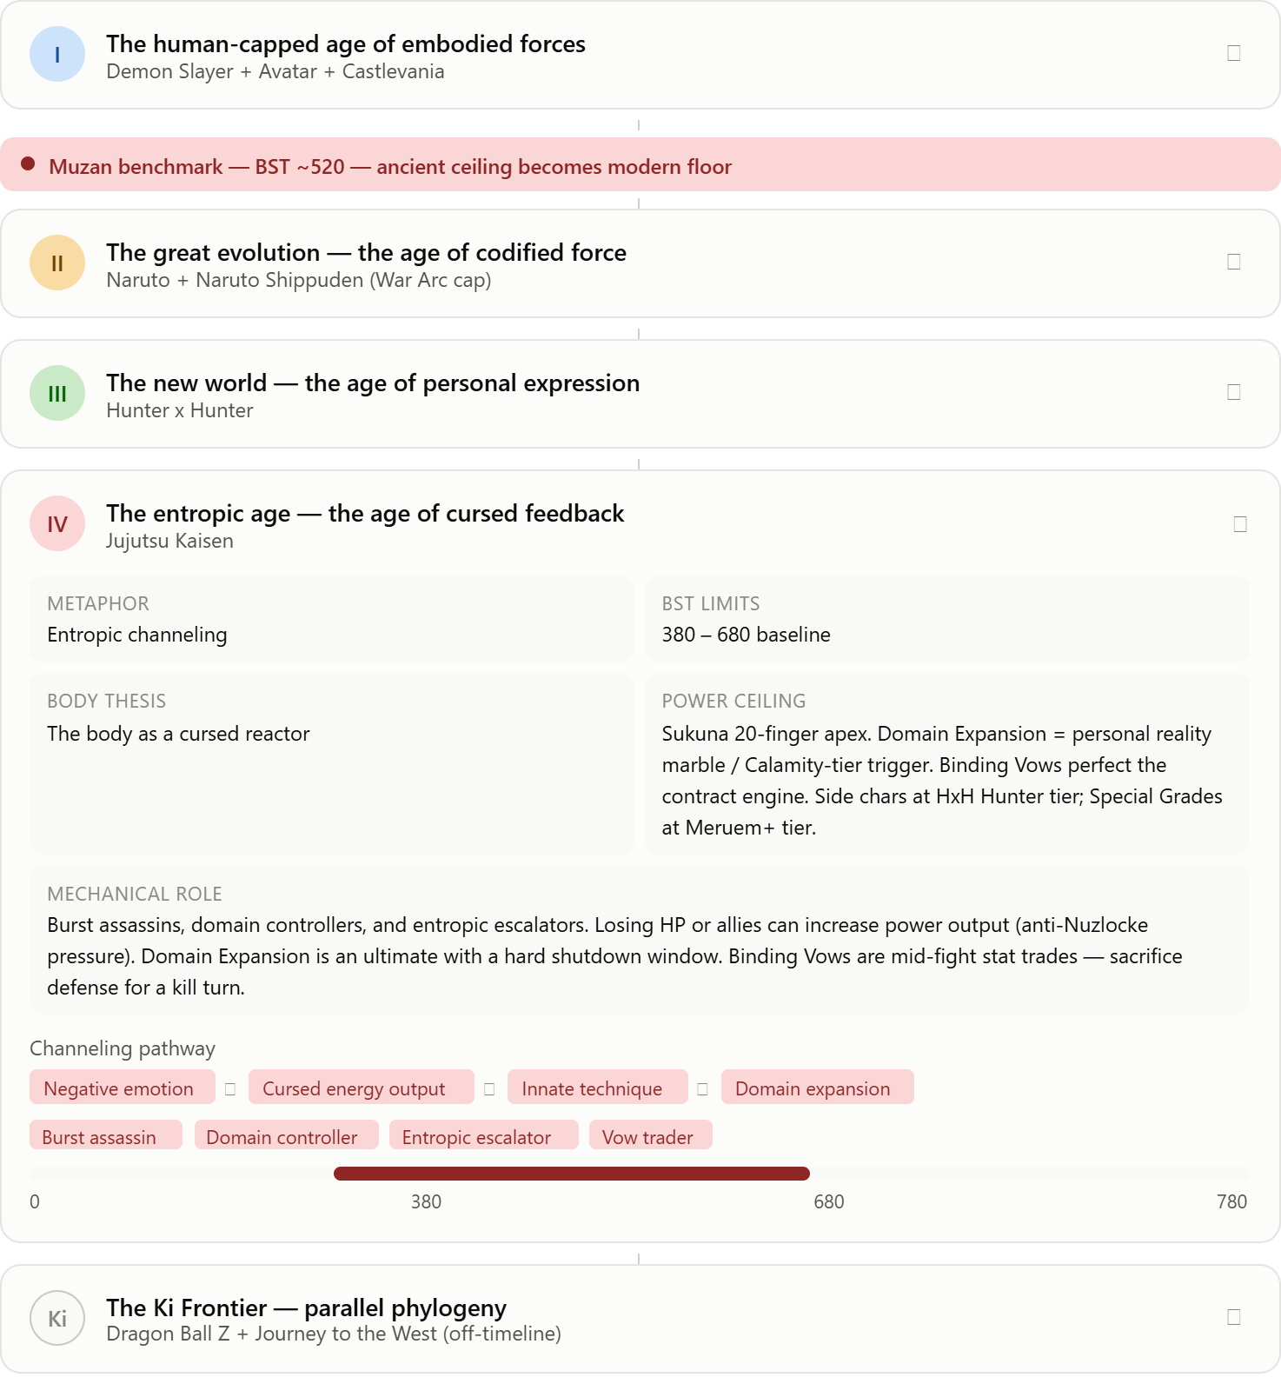

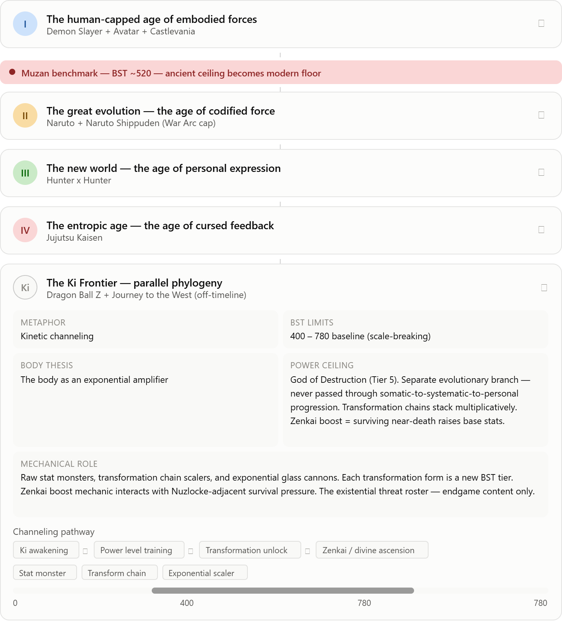

Era | Baseline (floor) | Fossil ceiling
I — Embodied forces | 300 → ~480 | Muzan benchmark ~520
II — Codified force | **starts at 520** | War-arc titles ~700
III — Personal expression | starts ~640–680 | Netero ~740
IV — Cursed feedback | starts ~720 | Special grades 780
Dark Continent | — | beyond the chart
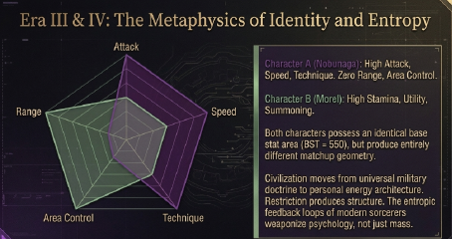
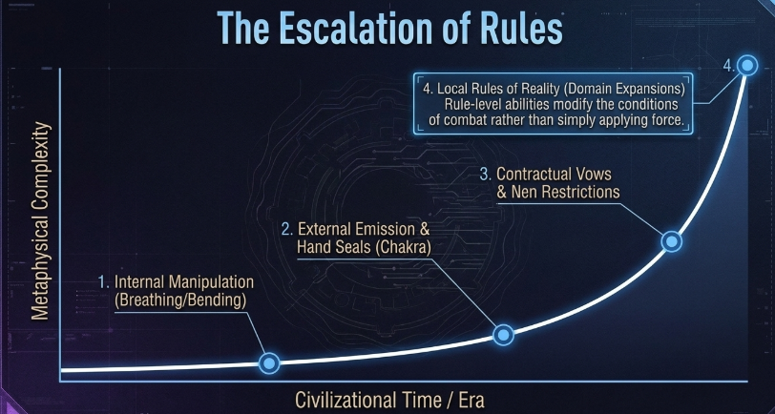
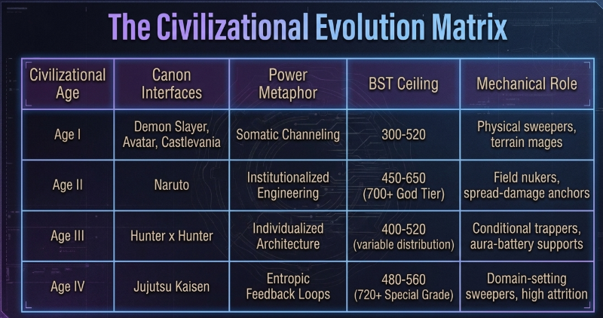

Stat | Abbreviation | Question it answers
Attack | ATK | How much damage per action?
Speed | SPD | Who acts first and how many times?
Technique | TEC | How precise, how complex, how punishing on crit?
Area Control | ARC | How much battlefield do you own?
Range | RNG | How far does your threat extend?
Stamina | STA | How long before you're spent?
comparison tool with a representative roster across all eras:
V
visualize
V
visualize show_widget

The Geometry Matchups — What the Hexagons Tell You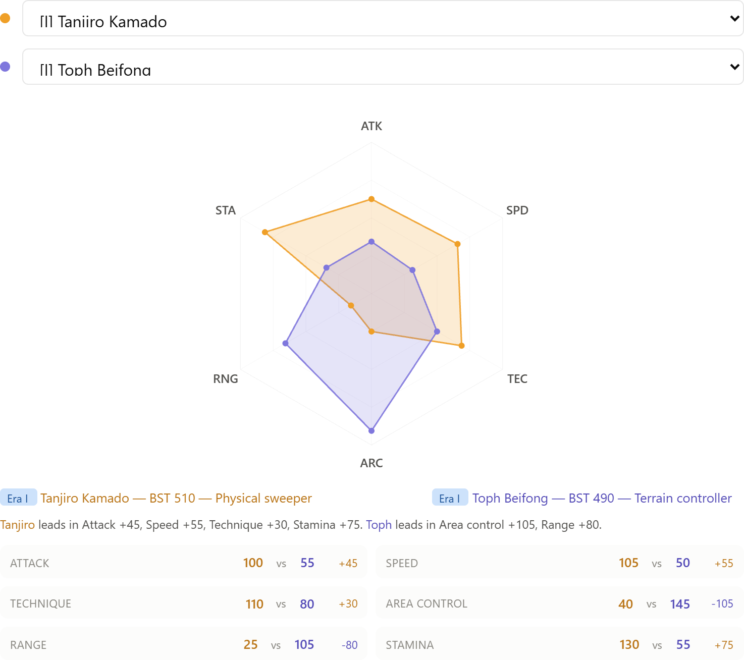
Try some comparisons to see the thesis in action:
Nobunaga vs Morel (your stub pair): Identical BST 550. Nobunaga's hexagon is a sharp dagger pointing top-left (ATK/SPD/TEC). Morel's is a wide shield pointing bottom-right (ARC/RNG/STA). Morel hard-counters Nobunaga because the matchup never enters Nobunaga's kill radius. But Nobunaga hard-counters anyone who has to stand still — his geometry punishes setup characters.
Shikamaru vs Might Guy: The brains-vs-brawn extreme. Shikamaru's hexagon is the inverse of Guy's — massive TEC/ARC with near-zero ATK/STA versus massive ATK/SPD/STA with near-zero TEC/ARC. Same era, completely different game plan. Shikamaru wins if the fight is decided by positioning; Guy wins if it's decided by contact.
Toph vs Gojo: Cross-era comparison that reveals why eras matter beyond BST. Toph (BST 490, Era I) has massive ARC/RNG — she controls the battlefield. Gojo (BST 670, Era IV) has massive everything except STA. The BST gap is 180 points, but Toph's ARC/RNG lead is only 25/15 points because Gojo's hexagon is so broadly inflated. The era difference isn't just "bigger numbers" — it's that Era IV characters have fewer weaknesses per BST point.
Kurapika vs Nanami: The condition specialist vs the technique executor. Nearly identical BST (~560 vs 540), both TEC-peaked. But Kurapika's hexagon is rounder (more adaptive) while Nanami's is sharper (more specialized). This is the Era III vs IV mechanical difference in one chart — conditions give you flexibility, innate techniques give you precision.
